**Practice Midterm Exam**

**Quantitative Methods**

**Aaron Hill**

**Fall 2011**

1. The following table summarizes the number of survey responses to a question about whether the welfare programs provided by the U.S. government were sufficient. The responses are shown by candidate the respondent voted for in the 2004 presidential election.

|  |  |  |
| --- | --- | --- |
|  | Voted for Kerry 04 | Voted for Bush 04 |
| Not enough welfare | 157 | 69 |
| Welfare is ‘about right’ | 220 | 195 |
| Too much welfare | 145 | 270 |

a. What percentage of respondents voted for Kerry?

b. What proportion of Bush voters believes there is too much welfare in the U.S.? What proportion of Kerry voters believe this? What proportion of all voters believe this?

c. What is the ratio of all Bush voters to Kerry voters? How do you interpret the result?

d. What conclusions would you draw from this table? Why?

2. Aunt Sally weighed 162 pounds on November 1. She weighed 179 on January 1. What happened? Calculate the percentage change in Aunt Sally’s weight.

3. The Glastonbury Music Festival is an annual event in the U.K. that was begun the day after Jimi Hendrix died. It is similar in nature to Woodstock in the U.S., except it has continued over the years and continues to be a popular destination for British hippies.

Because most people camp outside and there are no shower facilities, people stink. A precise scale of smelliness—taking in several factors—can assign a score that ranges from 0 (extremely smelly) to 5 (smells quite nice). From the Festival, a random sample of 123 people were gauged of their smell and assigned a score on this scale.

SPSS output on the following page shows the measures of central tendency and dispersion for this variable.

a. What is the central tendency of this variable? Cite relevant statistics and interpret.

b. How would you describe the *distribution* of smelliness? Cite relevant statistics and interpret.

c. How would you describe the *variance* of smelliness? Cite relevant statistics and interpret.

d. What is the *population* of this research? Can you estimate the true population value for smelliness? Cite relevant statistics and interpret.

e. What, if any, value does the graph offer in your understanding of smelliness at the Glastonbury Music Festival?

f. Interpret the Interquartile range.

**SPSS output for Question 3:**

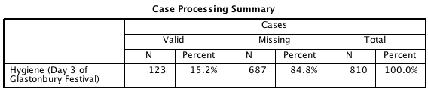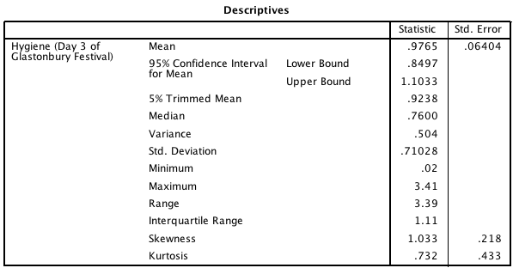

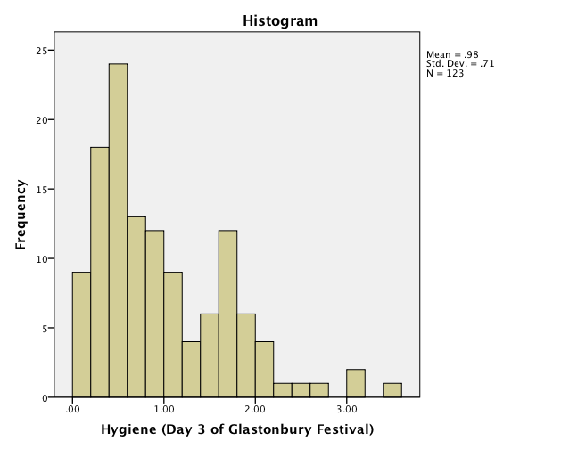

4. An SPSS exam was given at two schools: Duncetown University and Sussex University. As a researcher, you are interested in conducting a hypothesis test to determine if scores on the SPSS exam are different between the two schools.

a. How many variables are in this question? List them.

b. For each of the variable(s) in part a, define their level of measurement. For nominal and ordinal variable(s), include the number of categories/groups they have.

c. Which variable(s) is/are the dependent variables? Which variable(s) is/are the independent variables?

d. Using the 5-step Hypothesis testing framework, set up this hypothesis test. Using the SPSS output that follows on the next page, report and interpret the results. Remember to be thorough! All assumptions and details should be specified.

**SPSS output for question 4:**

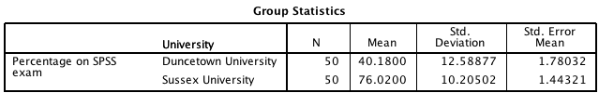

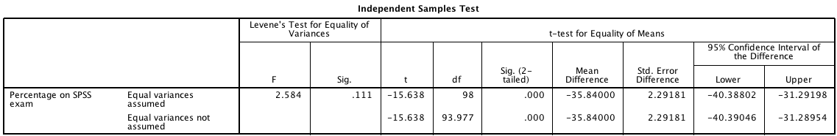

5. Bob and Suze recently took a standardized test. The mean score was 80, with a standard deviation of 10. Bob scored 75 and Suze scored 88. Assuming that the distribution is approximately normal, answer the following:

a. If 1,200 people took the test, how many people scored between Bob and Suze?

b. What percentage of people scored better than Suze?

c. What is the probability that a randomly selected person will have a score lower than Bob’s?

6. Rarely do we have the ability to get data on a full *population*. To understand such a population, we often take *samples* in order to make meaningful conclusions about a population. How is it that we are able to make inferential statements about a large population, from just a small number of people? In detail, describe the process of sampling and inferential statistics. Remember to discuss the assumptions and requirements of inferential statistics, the mechanisms that we use, and the underlying theory.

7. You are in charge of a poll to estimate the outcome of student government president elections. The poll includes responses from 791 randomly selected students. The results: Miss Popularity is ahead with 54% of the votes. But, Smart Alex is not far behind: 364 respondents said they would vote for him. At a 95% level of confidence, construct confidence intervals for Miss Popularity and Smart Alex.

Based on your findings, are you comfortable predicting a winner? Would you be comfortable predicting a winner at a 99% level of confidence?

8. A cruel experiment was performed in which people were shown a spider, and then tested for anxiety (measured on a scale; the higher the score, the higher the anxiety). Half of those in the experiment were shown a *real* spider, and the other half was shown a picture of a spider. The researchers wanted to determine if the anxiety levels were different for those who saw the real spider versus those who saw the picture.

a. How many variables are in this question? List them.

b. For each of the variable(s) in part a, define their level of measurement. For nominal and ordinal variable(s), include the number of categories/groups they have.

c. Which variable(s) is/are the dependent variables? Which variable(s) is/are the independent variables?

d. Using the 5-step Hypothesis testing framework, set up this hypothesis test. Using the SPSS output that follows on the next page, report and interpret the results. Remember to be thorough! All assumptions and details should be specified.

**Output for question 8:**

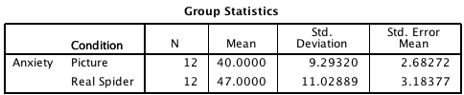

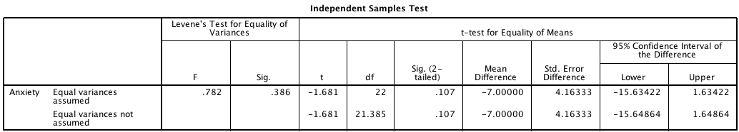

9. A weight-loss experiment is being conducted, and researchers recorded the starting weight of all participants. These participants were randomly selected among all citizens of the U.K. They are expected to represent the ‘typical’ British citizen.

SPSS output on the following page shows the measures of central tendency and dispersion for this variable.

a. What is the central tendency of this variable? Cite relevant statistics and interpret.

b. How would you describe the *distribution* of weight? Cite relevant statistics and interpret.

c. How would you describe the *variance* of weight? Cite relevant statistics and interpret.

d. What is the *population* of this research? Can you estimate the true population value for weight? Cite relevant statistics and interpret.

e. What, if any, value does the graph offer in your understanding of weight among these participants?

f. Interpret the Interquartile range.

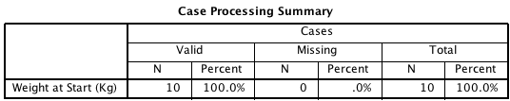

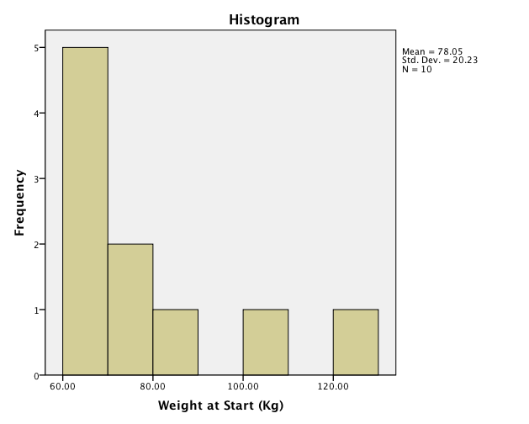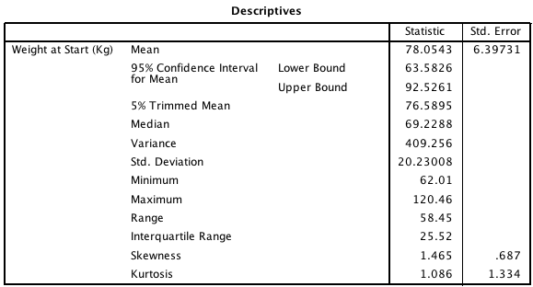

10. A random survey of 120 people found that people eat, on average, 8 cookies per week. The standard deviation of this variable is 5. What is your estimate of the cookie intake of the population?

11. Among households in which at least one person has a credit card, the average credit card debt is $15,788 (s=$20,835). What is the probability that a household will have more than $50,000 in credit card debt? Assume that credit card debt is normally distributed.

12. Short definition. Briefly define each of the following:

a. One-tailed test:

b. Two-tailed test:

c. Alpha:

d. Confidence level:

e. Sampling distribution:

f. The Normal Curve:

g. Standard Deviation:

h. Variable:

i. Hypothesis test: